Candidate Number:

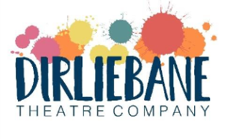

Application Form
For this role we are actively seeking and welcome applications from people who feel they’ve had fewer opportunities because of the financial circumstances of their background. This includes, though is not limited to, people who:
- had a parent or carer who was unemployed or in low paid or insecure work
- received free school meals or other forms of financial support
- have experienced financial barriers linked to caring responsibilities
- lived in areas with limited access to arts, culture, or extracurricular opportunities
- come from families who received benefits e.g. universal credit

We will not ask you to share personal details. We simply want to make clear that your lived experience is valued, and that we are committed to reducing barriers for people from low socioeconomic backgrounds.

You are welcome to apply using video or audio instead of a written application. This can be in any format that works for you: recorded on a phone, laptop, or other device. There is no expectation of high-quality production; we are interested in what you have to say, not how it is filmed or edited.

Application Questions
All sections of this form should be completed.
PLEASE NOTE: There is no need for long answers we are expecting 100 – 200 words per question.
Please tell us why you are interested in the role of Emerging Artist with Dirliebane.
Have previously done this kind of work?
(Tell us about any relevant work you have done before (if any) Remember we are looking for emerging artists)
What do you hope to gain from taking part in this opportunity?
(This might be about what you will learn, skills, contacts, confidence etc)
What can you bring to the role?
(This could be a chance to talk about relevant experiences, skills, or those which are transferable from other sectors)
What makes you laugh?
For example, for our Co-Artistic Director Rachel, it is Kermit the frog which always makes her laugh!
Anything else you would like to tell us?

